**Introduction to Zoom Meetings V.20.4 – 6/14/2020**

An introductory “How To” document to help people navigate and use the Zoom.com virtual meeting software.

**Table of Contents\*\***

Introduction

Quick Instructions for joining a meeting

Quick Instructions for starting a meeting

1. Some things you should do before hosting the meeting

1.1 If you need to install Zoom on your computer or device

2. As Host you start the meeting by first starting the Zoom app

2.1 As Host, you need to set Security unless you want to use the default security settings

2.2 Then invite people you want in the meeting that you started

3. What meeting participants should then do when they want to join a meeting

3.1 Joining a meeting using the Meeting ID from the invitation

3.2 What to do if your Host has required a meeting room

3.3 Using the Chat window to type messages to the other participants

3.4 Sharing windows on your screen to the meeting

3.5 Using Waiting Rooms to temporarily remove participants from a meeting

3.6 Using Breakout Rooms to create sub-meetings within a meeting

4. A Few things to keep in mind during a meeting

4.1 To end a meeting, and to quit Zoom

5. Creating and Using Contact Lists to make it easier to do impromptu meetings

5.1 How to populate your Zoom Contact List

Appendix A. Doing a Zoom invite using “Copy Invitation” and your email program

A.1 A review of how to use Copy & Paste for transferring text

Appendix B. Settings in the Zoom App client for controlling Meetings

Appendix C. Advanced settings in the Zoom.com website for controlling Meetings

Appendix D. Glossary of terms used in Zoom

Appendix E. A few articles about best practices, pros and cons of Zoom meetings

**\*\*Note: The Table of Contents is hyperlinked to Sections in this document. Hyperlinks in the rest of the document point to various web sites including Zoom.com. Click on a hyperlink (with Control-key or Apple key) to go to that section of this document or to an outside Website it is linked to. You can go back to where you came from by pressing the ALT-Left Arrow in your PDF reader and Word, or the Back Arrow button in your Web browser.**

**NOTICE**

Thanks to many people for their feedback, suggestions and corrections on this document. If you have suggestions, email them to [IntroToZoom@gmail.com](mailto:IntroToZoom@gmail.com) and we may incorporate them in future revisions as time permits.

Feel free to take this document, edit it as you wish and pass it on to help others learn how to use Zoom.

The home page for **Introduction to Zoom Meetings** is on GitHub where it contains links to the latest version you can download as a Word, PDF or HTML document.

<https://github.com/IntroToZoom/ITZ/blob/master/README.md>

**Introduction**

This is collection of some “How To Zoom” discussions we found useful having been recently introduced to using Zoom because of the COVID-19 pandemic and social distancing. Zoom is far from perfect, but is a useful tool in the current situation we are all experiencing. We hope you find it useful.

The Zoom program from [Zoom.com](https://Zoom.com/) lets one user, called the **Host**, start a video meeting and invite others, called the **Participants**, by sending them an email invitation or by directly inviting them through a Zoom contacts list (see **Section 5**). The person receiving the email clicks on a link to start downloading Zoom and then joins the meeting.

To host a meeting, they must have Zoom installed on your device and have a Zoom account (free or paid). They must have Zoom running in order to see and respond to the various Zoom commands, icons, etc. (see **Section 1.1**) which starts with how to install Zoom, acquire a free zoom account and run Zoom. Anyone the host invites to a meeting can run their Zoom client they have previously installed or for someone who has never installed Zoom, the email link will lead them in installing Zoom and then join the Zoom meeting.

Note: this document is a work in progress to help clarify some of the essentials on how to use Zoom. Figures are numbered within each Section. E.g., 1.1, 1.2, etc. to make it easier to insert new figures.

In this document, you will see some underlined blue hyperlinks (like [Zoom.com](https://Zoom.com/)) which link to particular documentation on the Zoom and other web sites. If you are using the Word docx version of this document, youclick (while holding the Control-key or the Apple-key on Macs) on the hyperlinked (i.e. underlined blue) phrase. It will bring up the Web page in your Web browser. In the Web version, just click on the hyperlinked phrase. Note that buttons and key words in the Zoom windows are indicated in black Bold. These are *not* underlined. And sometimes indicated as **Red**, **Orange**, **Green** or **Blue** bold as they appear in the Zoom windows.

There is extensive documentation on the [Zoom.com](https://Zoom.com/) website under their [Support](https://support.zoom.us/hc/en-us?flash_digest=f7974147c2b29a68a2eb7cab563d00c68b6325d7) help page. The Zoom home page **Resources** pulldown menu has additional documents for details on:

* [Download Zoom Client](https://us04web.zoom.us/download#client_4meeting)
* [Video Tutorials](https://support.zoom.us/hc/en-us/articles/206618765-Zoom-Video-Tutorials)
* [Daily Live Training](https://us04web.zoom.us/livetraining)
* [Top 20 Most Commonly Used Support Resources](https://support.zoom.us/hc/articles/360042982391)
* [5 Things to Know about the New Zoom 5.0](https://blog.zoom.us/wordpress/2020/04/27/its-here-5-things-to-know-about-zoom-5-0/), April 27, 2020
* [Webinars and Events](https://us04web.zoom.us/events)
* [Zoom Blog](https://blog.zoom.us/)
* [FAQS for Users and Participants](https://support.zoom.us/hc/en-us/articles/206175806)
* [Privacy and Security](https://us04web.zoom.us/docs/ent/privacy-and-security.html)
* [Security Resources](https://us04web.zoom.us/security)
* [Plans & Pricing (including the Free version for 40 minutes and 100 people)](https://zoom.us/pricing)

We will not be going into the details on these resources. If you are interested, then investigate them further on the Zoom.com website.

The Zoom application has its own jargon. There is a Glossary of some Zoom terms in **Appendix D**. And some links to articles about best practices, pros and cons of Zoom in **Appendix E**.

**Quick Instructions for joining a meeting**

This short overview is on how to join a Zoom meeting if you get an invitation to join a meeting. It assumes you have never used Zoom before.

You will get an Email that looks something like the following.

*Join Zoom Meeting*

*https://us04web.zoom.us/j/954031295?pwd=U2E0VEszQWNoUmtUaWFibTFlUU42dz09*

*Meeting ID: 954 031 295*

*Password: 4GE0jT*

**Figure Q.1** An **example of a Zoom meeting invitation**. It has a URL (Web link**)** that the participants may click or copy to a Web browser. It will also have a **Meeting ID** and **Password** that the participants can use with their previously installed Zoom client program to join a meeting. This which will be discussed later.

To summarize, to join the meeting, click on the URL or copy and paste it into your Web browser and go to that link. It will go show some additional windows (discussed in **Section 3.**). If all goes well you will enter the Zoom meeting. Alternatively, you can join a meeting using Zoom if it was previously installed on your device by using the **Meeting ID** number and **Password** from your invite. Click on the **Join** button in **Figure 2.2.** that pops up **Figure 3.4.a**. and then enter the Meeting ID number and press the Join button **Figure 3.4.b**. For more details, see **Section 1.1** and **Section 3.1**.

**Quick Instructions for starting a meeting**

Start the Zoom program (app) on your device. It will ask you to log in to your Zoom account as is shown in **Section 2**. You then click on **New Meeting**. After the meeting is started, click on **Participants**. that brings up a Participants window. Click on **Invite** at the bottom of the window. Then click on **Email** and then **Default Email**. When your mail program comes up, enter the email addresses of the people you want to invite to the meeting and send the email. At that point, sit back and wait for the people to join the meeting. **Section 2** goes into this procedure in more detail. Note that you can’t host two Zoom meetings on different devices using the *same* Zoom account. It will ask if you want to close the older meeting.

**1. Some things you should do before hosting a meeting**

Send an email or talk with participants to agree on the time and date for the meeting – a time when everyone can meet. Let them know they should be looking for an email with a meeting invitation just before the meeting. You should have Zoom installed on your device or computer. The person joining your meeting does not need to have Zoom installed before the meeting. It will go faster if they do, but it is not necessary.

**1.1 If you need to install Zoom on your computer or device**

Reiterating, if you have never installed Zoom on your device, you need to install it before running a meeting and you need to sign up for a Zoom account. Go to [Zoom.com](https://zoom.com/) on your Web browser. And enter an email address and press on **Sign Up Free**. They may ask for a birthdate (it does not have to be your real birthdate). Then press **Continue**. Zoom then emails you an acceptance email. Look in your email (maybe check your junk/spam folder) to read the email and click on the button in the email to **Accept** the Zoom account. This then brings you back to the Zoom website where you enter the name you will use in Zoom sessions (again it does not have to be your real name). You can skip the part asking you to invite other people to join zoom. It will then try to download and install the Zoom app on your computer or device. You can install Zoom on your other devices by going to their [Download](https://us04web.zoom.us/download#client_4meeting) web page for a variety of devices including Windows, Macs, Linux, Android, iOS devices.

**2. As Host, you start the meeting by first starting the Zoom app**

Click on the **Zoom** app Icon on your device to start your local Zoom program. It may appear on your task manager or desktop or some other location where installed programs are kept. In Windows, it will be in the *Start* menu. On the Mac it will be in the *HD Applications* folder, etc. It may appear on your desktop or wherever install applications are found on your device. It should look like this . Note: This is for the app, ***not*** for the website zoom.com. Next, sign into the Zoom app with your email address and Zoom password that you created when you first signed up for Zoom.



**Figure 2.1.** Shows the **Sign In window**. This will look different on different devices, but the information is the same. After signing in with your Zoom email address and password (the left two entry forms), a control panel will pop up. If the window does not look like the next **Figure 2.2**, click on **Home** button (first row) so that it has the four icons: an orange **New Meeting**, and the blue **Join, Schedule,** and **Share Screen**. Note that if you did not Quit Zoom, then this login window will not appear and instead it will bring you to the window shown in Figure 2.2. Once you have signed in and Zoom is running, you do not need to sign in again when starting a meeting from the email Invite or after ending a zoom meeting until you sign out.

You will use the **New Meeting** and **Join** buttons to start a new meeting and to join an existing meeting respectively.

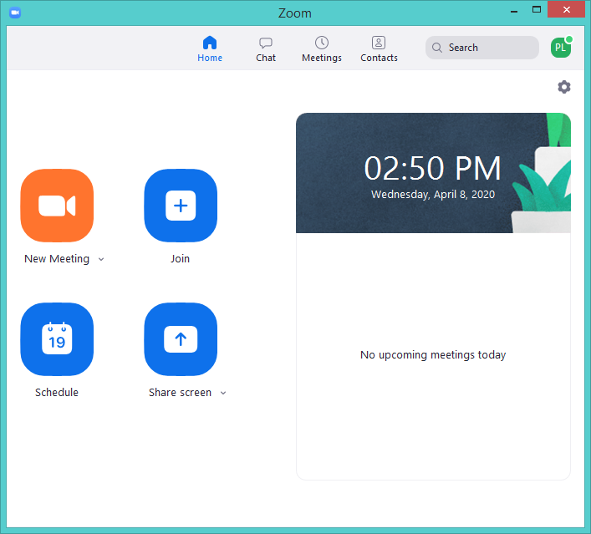

**Figure 2.2**. After you have signed in you will see the four icons **New Meeting**, **Join, Schedule,** and **Share Screen**. Click on the **New Meeting** to start a new meeting. By starting a new meeting, you are by definition the *Meeting Host*. We will discuss some of the other controls **Chat**, **Meetings**, **Contacts** later. People who later join the meeting are the *Participants*.

The next figure shows the Zoom window with the Zoom Control icons. They appear on the bottom of the window in Windows PCs, Macs, Android tablet, iPhone. They appear at the top of the window for the iPad, Android cell phone. Whether the participants can have the Zoom session controls always visible depends on the host’s zoom.com settings. If it is not visible, they have to move the mouse or touch the screen to make them appear. This setting is shown in **Appendix C** **Figure C.1.4** “Always show the meeting control bar”.



**Figure 2.3.** This figure shows the Zoom meeting window with Controls for the Host. When the Zoom meeting starts, it shows the following Zoom meeting controls (located at the bottom for Windows, at the top for Apple devices. Some devices like tablets and smartphones have some of the controls located in other places. They may have a “**… More”** where **Chat** and **Meeting Settings** may be located). From left to right it shows the **Unmute/Mute** audio to turn your devices microphone on and off. The **Start Video/Stop Video** to turn your devices camera on and off. The **Security** icon only appears on the Host’s screen and is discussed below. The **Participants** button is used to show participants in the meeting and to **invite** new participants to the meeting. It also lets them **Mute Me** (themselves) or **Mute Al**l (everyone in the meeting). The **Chat** button is used to type messages to other participants during the meeting. The green **Share Screen** button can be used to share your screen if it is enabled. **Breakout Rooms** if they are enabled. The **Reactions** are buttons to put icons on your image for “raise hand” or “Thumbs up”. The Host has as red **End** they can use to end the meeting. On participants screens is a red **Leave**.



**Figure 2.4.** The Zoom meeting controls seen by the **Participants**. Notice they do not have the **Security** icon (since only the Host can set security).

**2.1 As Host, you need to set Security unless you want to use the default security settings**

You may have noticed the **Security icon** 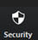 on the Zoom window. As Host, you may set some options here each time you start a meeting instead of going into the Zoom system settings where they can be set as a default. For security, Zoom has what they call a **waiting room** where people will go first when they join your meeting. The meeting Host then may allow individuals in the waiting room to join the active meeting. They can add participants either one by one, or everyone if they recognize the participants. The Host can allow or restrict participants ability to share their screen and enter comments by enabling their **Share Screen** and **Chat** buttons.

**a)**  and **b)** another setting 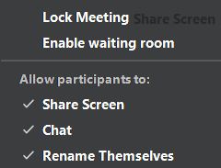

**Figure 2.5**. The **Security** icon gives the meeting Host addition options. The host can **Enable/Disable** various options before the host sends invites to the meeting. This is how the host can disable the use of the meeting room. (It can also be disabled in the **Settings** in your [Zoom.com](https://zoom.com/) account.) Example a) is more restrictive than b).

**2.2 Then invite people you want in the meeting that you started**

You do this by emailing them what Zoom calls an **Invite.**  First click on the **Participants** and scroll down to the bottom left where they put the **Invite** button. Depending on your version of the Zoom app it will be in one or the other locations on the screen. Then click on **Invite**. If enabled by the Host settings, Participants can do their own Invites to other participants themselves.

There are two ways to send an invite: by email and by using your Zoom contacts list. We will discuss email invites in this Section 2. We will discuss sending invites using a **Zoom Contact Invite** in **Section 5**.



**Figure 2.6.** The **Participants** popup window. To **invite** other participants, click on the **Invite** button in the lower left of the window. This will bring up the **Invite People to Join Meeting** window. The Host can **Invite**, **Mute All** and **Unmute All** participants. There are additional controls that the Host can change by clicking on the “**…”** in the lower right.

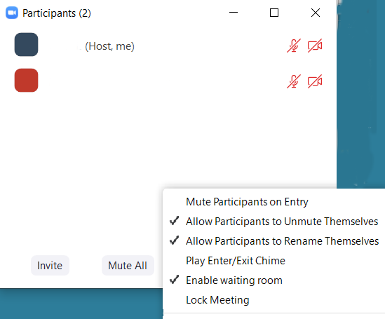

**Figure 2.7.** Shows the additional controls that the Host has in the **Participants** windows when the click on the “**…”** in the lower right (seen in the *previous* figure). The **Lock Meeting** option lets the Host freeze the meeting size by setting this option at any point. They may then unlock the meeting as needed (see more details in Zoom documentation and [Managing a Meeting](https://support.zoom.us/hc/en-us/articles/115005759423-Managing-participants-in-a-meeting)).



**Figure 2.8**. This is the **Invite window**. To send out email invitations, first click on the **Email button** at the top. We now discuss how to send an invite.

There are several ways to send an *email* invite. If your computer or device uses standard email systems, you may be able to use one of *choose your email services* buttons **Default Email**, **Gmail**, **Yahoo Mail**. The **Default Email** may work for you, in which case it is the easiest way to do an **Invite**. Click on it and it will bring up your email program to compose an email with the invite already in the message part of the email. You then just enter the email addresses for the people you want to invite and send the email.

However, if you have a problem using this on some computers and devices, there is another method that *always* works and is described in **Appendix A**. *Instead* of using one of the Zoom mail service selections shown, click on **Copy Invitation** at the lower left (which copies the invitation to the computer clipboard (this is *equivalent* to the copy operation from Copy & Paste editing options in computers and devices). Note: on a tablet or phone it might only have **Copy URL**, in which case click on that. See Appendix A for more details on using this alternative invite method.

The invitation will look something like this example:

*Join Zoom Meeting*

*https://us04web.zoom.us/j/954031295?pwd=U2E0VEszQWNoUmtUaWFibTFlUU42dz09*

*Meeting ID: 954 031 295*

*Password: 4GE0jT*

**Figure 2.9.** An **example of a Zoom meeting invitation**. It has a URL (Web link**)** that the participants can click or copy to a Web browser. Alternatively, it will have a **Meeting ID** that the participants can use with their previously installed Zoom program to **Join** a meeting. The Invite may or may not have a **Password** depending on the Host’s system settings that may or may not require using a password. If a password is missing, this is because the Host did not require a password and so participants won’t need to enter it when they join a meeting.

**3. What Participants need to do to join the meeting**

Invited participants should check for the email you just sent and then open it. They may then join the meeting two ways:

1. Participant join a meeting by clicking on the URL (Web link**)** in the email. Alternatively, they may copy and paste the link into their Web browser and then go to that web site. They should then agree to join the meeting. If the invitee is *already* logged into the Zoom app, it will show the Web page in **Figure 3.1**. If the invitee is not logged into the Zoom app, it will download a file which they might have to click on. See the next figure that the invitee will click on to join the zoom meeting.
2. Participants can join a meeting a second way by first starting their Zoom app. Click on the blue **Join** button when it appears. It will ask for a Meeting ID. Then copy & paste or type in the **Meeting ID** from the email. It may ask for a **Password**, in which case copy & paste or type in the password from the email Invite.

If it asks you to **Join With Computer Audio**, always do that. This is needed if you want to unmute or mute your audio later on to speak in the meeting.



**Figure 3.1.** This is the web page that is brought up in your browser when you **click on the Invite URL web link.** When launching Zoom, it checks to see if Zoom was already installed. If not, you will see the browser window shown in Figure 3.2. Be patient since it may take a while to launch.



.

**Figure 3.2.** If the invitee Zoom app is not running, it may ask you to **Save file** and then click on it to **join** the meeting. Some devices may allow you to **Open file** so Zoom will start by itself.



**Figure 3.3**. **Save the file** and then click on the saved file to **join** the meeting (this example is for Windows. It will be different on other devices). Running this program will start Zoom and delete this startup file.

**3.1 Joining a meeting using the Meeting ID from the invitation**

Alternatively, you can join a meeting using Zoom previously installed on your device by using the Meeting ID number from your invite. Click on the **Join** button in **Figure 2.2.** that pops up **Figure 3.4.a**. and then enter the **Meeting ID** number and the name you want to use, and press the **Join** button **Figure 3.4.b**.

**a)** 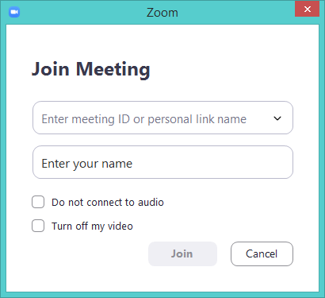

**b)**  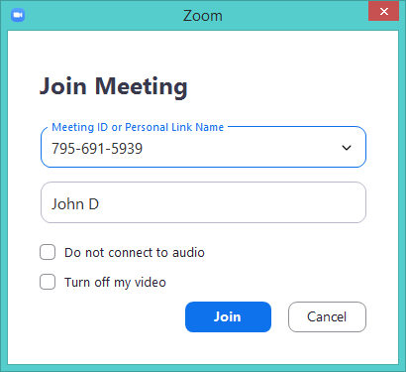

**Figure 3.4.** You can join a meeting by clicking on the **Join** button shown in **Figure 2.2** in **Section 2**. It then pops up this window. Enter the Meeting ID number (spaces and “-“ are ignored). Enter your name. b) Then the **gray** Join button turns blue **Join**. Click on that to join the meeting.

**3.2 What to do if your Host has required a Waiting Room**

You may be directly admitted to the meeting, but if the Host has enabled waiting rooms, participants may be placed in a **waiting room** until the Host has **admitted** them to meeting. The participants will see a popup window shown here.



**Figure 3.5.** The popup window participants will see if there is a **waiting room**. They must wait until the Host admits them by going into the **Participants** window and then letting them in.

The Host must check their waiting room to see if anyone is waiting to be admitted to the meeting. They can **Admit** individual participants or **Admit All**. The Host then clicks on **Participants** to bring up the **Participants** window.

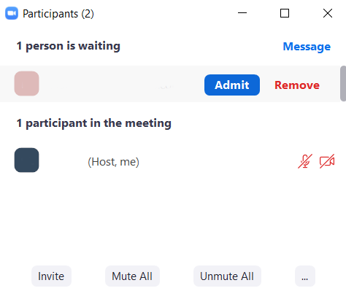

**Figure 3.6**. The Host’s **Participants** popup Window. If the Host started a meeting with a **waiting room** enabled, they should check for anyone being in the **Waiting Room** so they can admit them. They can then **Admit** them or **Remove** them (in the case of removing someone who might disrupt or [*Zoombomb*](https://en.wikipedia.org/wiki/Zoombombing) the meeting).



**Figure 3.7**. Shows **the non-host Participants** Window. They do not have the **Mute All** button that the Host has in their participants window. By clicking on the **“…”** additional commands will popup. The **Raise Hand** option puts a raised hand in your image on the meeting so the Host can call on you in a discussion.

**3.3 Using the Chat window to type messages to the other participants**

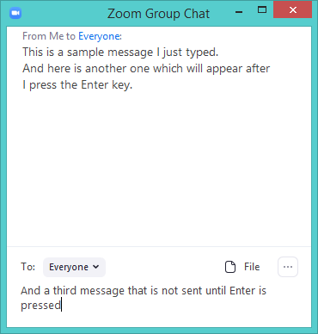

**Figure 3.8.** Pressing the **Chat** button in the controls pops up a window where you may send a public message to **Everyone** or a private message to an individual participant (by selecting them in the “**To:”** menu at the bottom of the window). The message is sent after you type the message and then press the Enter key. Chat is useful to participants to make comments for the group to see during a meeting or to ask a question or request they be called on to speak.

**3.4 Sharing windows on your screen to the meeting**

One of the useful options in Zoom is to share your screen or a particular window currently visible on your screen. This can be useful for sharing photos (or videos) as well as documents for group review or editing. The Zoom settings must be set to allow screen sharing which is allowed/restricted in the Zoom Settings in **Appendix B** and **Appendix C**. As Host, you may restrict screen sharing to yourself, or allow other participants to share your screen. As Host, you can stop other participants screen sharing. You can also allow (potentially dangerous) participants to control the application in the shared screen, as for example several people editing a document.

To start sharing a window on your screen, click on the **Share Screen** icon in the Zoom Controls in **Figure2.3**. This will pop up a window with icons representing the visible windows. Click on the one you want to share. This will then share the screen with everyone. The Host or particular participant sharing the screen will have a **Stop Sharing** icon at the top. Clicking on that stops the screen sharing.

**a) Screen sharing selection popup window.**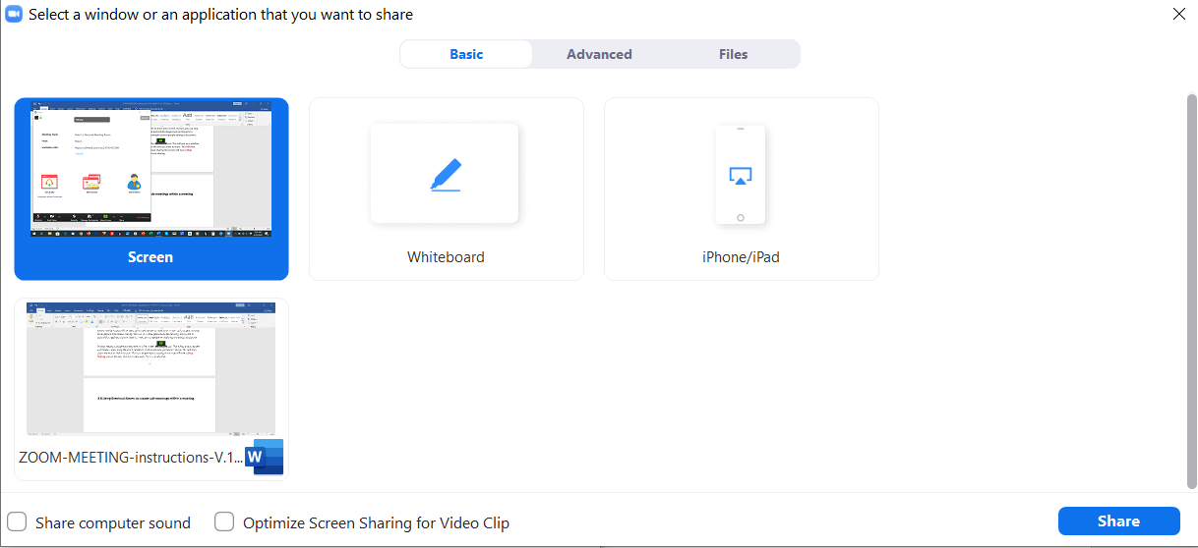

**b)** **Screen sharing controls at the top of the screen being shared for the participant sharing their screen.**

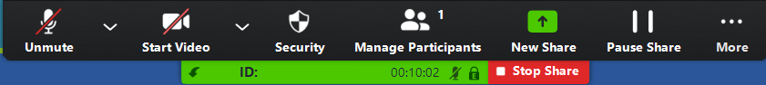

**Figure 3.9.** Example of the a) popup **Screen Sharing selection window** showing Icons of possible windows to share. You select the icon of the window to share and then click on the **Share** button to share that screen with the other participants. b) Screen sharing controls at the top of the screen being shared for the particular Participant sharing their screen. You can stop the meeting by clicking on **Stop Share** Button.

**3.5 Using Waiting Rooms to temporarily remove participants from a meeting**

There may be situations where you have several participants in a meeting and you need to ask some of them to wait outside the meeting while the remaining participants discuss things or review documents without them. If you have **Waiting Rooms** enabled on your **Advanced** Zoom.com settings (see **Appendix C.1.6**.), you can temporally remove them and then add them back later. You can do this manually selecting particular participants for particular rooms or let it assign them automatically.



**Figure 3.10.** Once a meeting is going, the Host may put participants into the **Waiting Room** by selecting the **More** option in the Participants window and then selecting **Put in Waiting Room**.



**Figure 3.11.** Later, the Host can re-**Admit** Participants back into the Meeting from the Waiting Room. If they select **Remove**, the Participant is removed from the meeting and cannot enter the meeting again.

**3.6 Using Breakout Rooms to create sub-meetings within a meeting**

Breakout Rooms are sub-meetings that can be set up by the Host (if enabled in their settings – see **Appendix C.1.6**) by assigning individual participants to these separate sessions. The Host may then bring the Participants in the Breakout Rooms back into the larger meetings. To make things go smoothly the host should explain to the participants, if they have never used breakout rooms, what will happen. 1) The host will put participants into different Rooms with a subset of the people from the main meeting room. 2) When this happens, the main meeting room disappears and after a few seconds it asks it they **Accept** going into a Breakout Room. 3) They may have to UnMute and Start Video (depending on how the Host has these options setup). 4) They can **Leave** the Breakout Room at any time and will be returned to the main Meeting Room after a few seconds, or the Host can **Close all Rooms** to bring people back to the main Meeting Room. 5) Again, they may have to UnMute and Start Video (depending on how the Host has these options setup).



**Figure 3.12.** If Breakout Rooms are enabled, then this is what the **Breakout Room** button looks like on the Zoom Control buttons.

The Host would first click on **Breakout Rooms** to create 1 or more rooms.

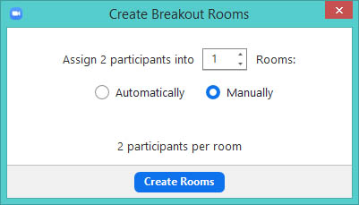

**Figure 3.13.** The Host then can create 1 or more **Breakout Rooms** and **Assign** participants to the rooms **Manually** or **Automatically**. The Manual option was selected in this example and lets the host assign particular participants to particular rooms.

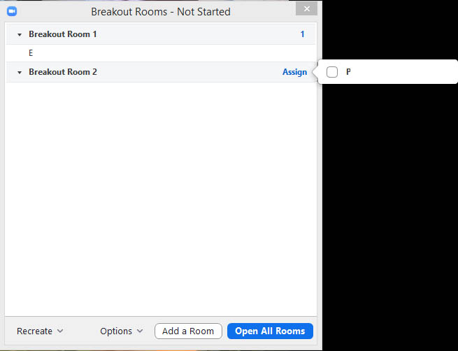

**Figure 3.14.** This example shows how a Participant is assigned to a **Breakout Room**. One was previously **Assign**ed and a new room added with the **Add a Room** button**. Open All Rooms** starts the breakout rooms, but first removes them from the main meeting room. Be patient as it may take several seconds for the breakout rooms to open. Each of the Participants will get a popup window asking them to **Accept** going into their breakout room.

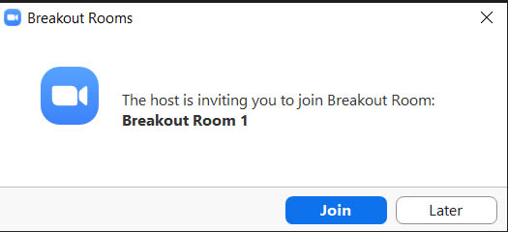

**Figure 3.15.** The Participant gets an invitation they must **Join** to go into the Breakout Room they have been assigned by the Host.

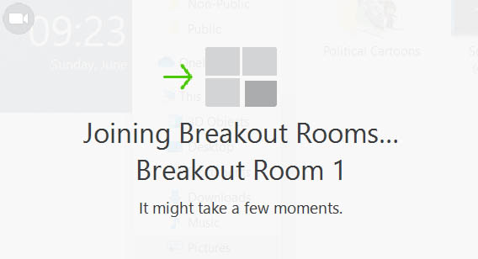

**Figure 3.16.** This is the message a participant gets while waiting to be switched into a Breakout Room from the main Meeting Room. It can take several seconds, so be patient.

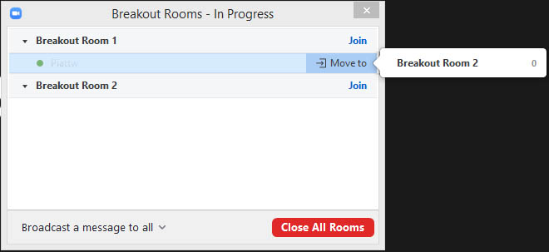

**Figure 3.17.** This example shows how the Host can move a Participant to from one Breakout Room to another Breakout Room by selecting the participant’s **Join** button and then responding **Yes**. They can also move a Participant to from one Breakout Room to another Breakout Room and click on the **Move to** option and then selecting the Breakout room to move them to. The **Close all Rooms** button ends the Breakout Rooms and brings everyone back to the main meeting. Be patient as it may take several seconds to bring everyone back to the main meeting room. Note that when entering a meeting room or returning to the main meeting, if the host has set the zoom.com settings to start meetings with Muted audio, then the host and participants need to Unmute their audio each time they enter a meeting room or the main meeting. The host might advise the participants to do this after opening and closing meeting rooms.

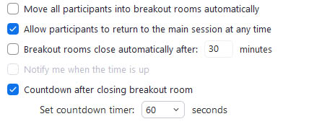

**Figure 3.18.** This Host has additional options when running Breakout Rooms.

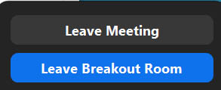

**Figure 3.18.** The Participant Leave decide to **Leave Meeting** or **Leave Breakout Room** at any time while they are in a Breakout Room.

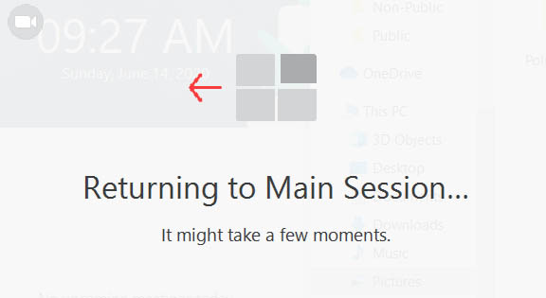

**Figure 3.19.** This is the message a participant gets while waiting to be switched from a Breakout Room back to the main Meeting Room. It can take several seconds, so be patient.

**4. A Few things to keep in mind during a meeting**

The **Mute** and **Unmute** buttons on their screens control each participant’s microphone audio. A *large* meeting becomes untenable when too many people are talking in the background, the phone rings, and miscellaneous noise, etc. Consider muting yourself when not speaking in a lecture type setting. The background noise of large numbers of people can easily disrupt the meeting. You can unmute yourself in such situations. In addition, the meeting Host can mute and unmute anyone by clicking on the **Mute** and **Unmute** buttons in their **Participants** popup window.

People can agree on how to signal when they want to speak. Raising their hand in their video (or the “hand” icon) works for small groups. For large numbers, the **Chat** window may be better for asking questions or requests to speak. Having another Participant read questions in the Chat window to the Host who is giving a presentation can be useful.

All participants can control whether their device camera is on or off using the **Start Video** and **Stop Video** buttons.

There are two main ways to view the meeting. **Speaker** view which has whomever is speaking in a large image in the center of the screen and **Gallery** view where everyone is in a grid of small windows. The former is most useful listening to the main speaker presentation or screen sharing, and the latter when meeting with friends or colleagues with a particular person running the meeting.

If there is an annoying echo, it is because one or more participant’s speaker volume is too high. This can often be fixed by having them lower their speaker volume, muting them or have them **Mute** themselves (especially with many participants). An alternative is to have them or the Host of some Participants wear earphones to break the feedback loop.

**4.1 To end a meeting, and to quit Zoom**

The Host can click on the **End** to end the meeting for everyone. Any other person in the meeting can individually **Leave** to leave a meeting. If the Host set their system setting to allow the meeting to continue after they **Leave** rather than **End** the meeting, it can continue for the other Participants. If participants leave a meeting, they may or may not be able to re-enter the meeting depending on the meeting Host’s system settings. Note that the Zoom program will not end, just the meeting. To close the Zoom program itself, you need to force the Zoom program to **Quit** as shown in **Figure 4.1**.



**Figure 4.1.** Shows the popup menu when you click on the profile icon in the upper right corner. Notice the **Sign Out** button at the lower right. Clicking on that stops the Zoom program completely so that you will have to log in again the next time you run Zoom.

a)  b)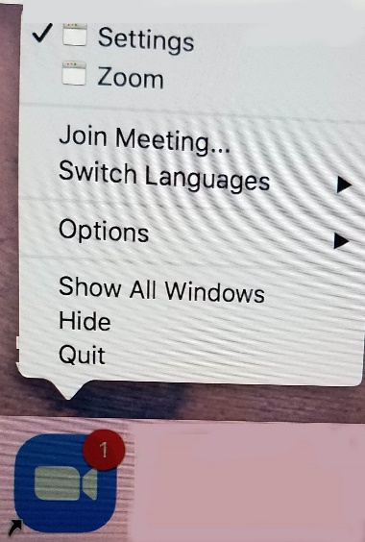

**Figure 4.2.** a) On Windows, this shows the popup window if you **right-click** on the Zoom icon on the Windows or Apple task bar (the blue circle with the camera inside it). Notice you can sign out of Zoom by clicking on the **Quit Zoom** button. In addition, you can start Zoom by clicking on the **Start Zoom** button. b) on the Mac **Control-click** on Zoom icon and then click on the **Quit**.

**5. Creating and using Contact Lists to make it easier to do impromptu meetings**

An alternate way to quickly start an impromptu meeting is to use **Contacts**. When you do an invite, you have the choice of sending an email invite (as discussed in Section 2.2) or use another method to select participants from your Zoom **Contacts List**. We will discuss how to add people to your Zoom Contacts list in **Section 5.1**. Note: This contacts list is part of your Zoom client. It is *not* part of your email system or operating system.

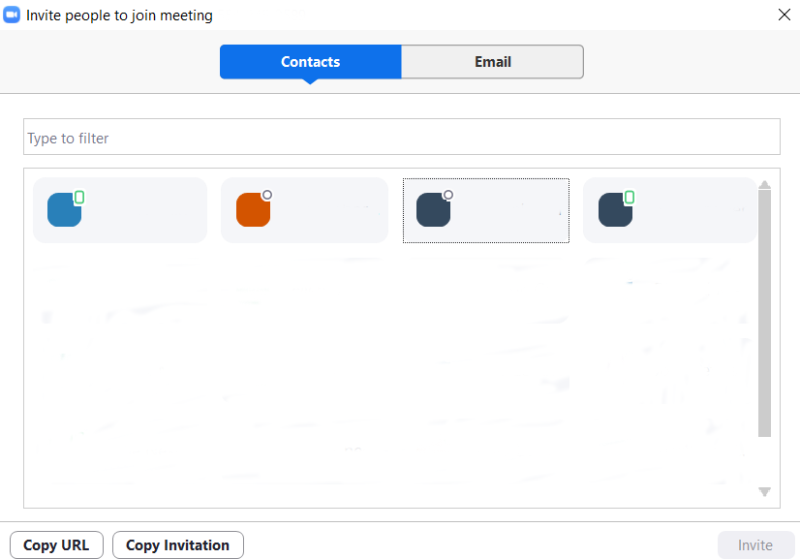

**Figure 5.1.** Shows a typical **Contacts List** when the user clicks on the **Invite** in the **Participants** windows. The names of the contacts have been removed in this example. Notice the **Invite** button is grayed out.

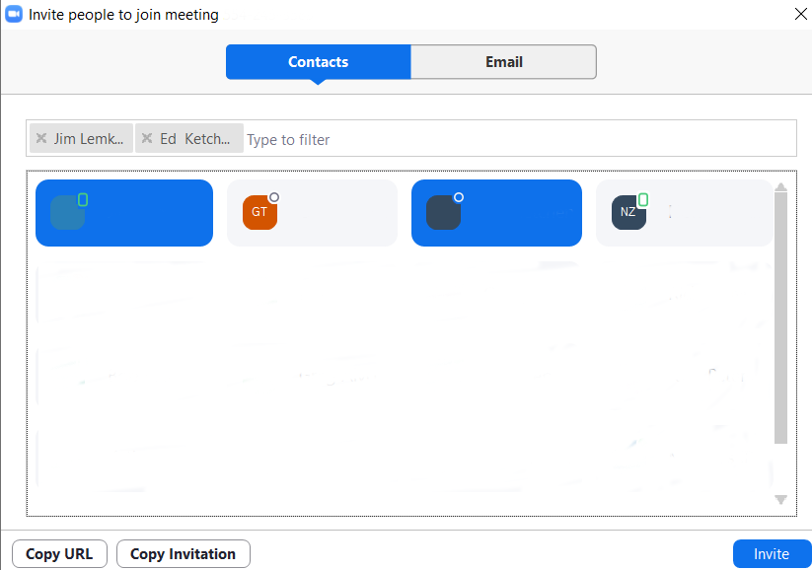

**Figure 5.2.** Click on the people you want as Participants. Then, click on the **Invite** button (which is now blue). If their Zoom apps are running, they will get an **Invite** directly without having to go through their email programs.

**5.1 How to populate your Zoom Contact List**

You add people to your Zoom **Contact List** by sending people a **Contact Invite**. First go to the main window, which opens when you start your Zoom app. Then click on **Contacts**.

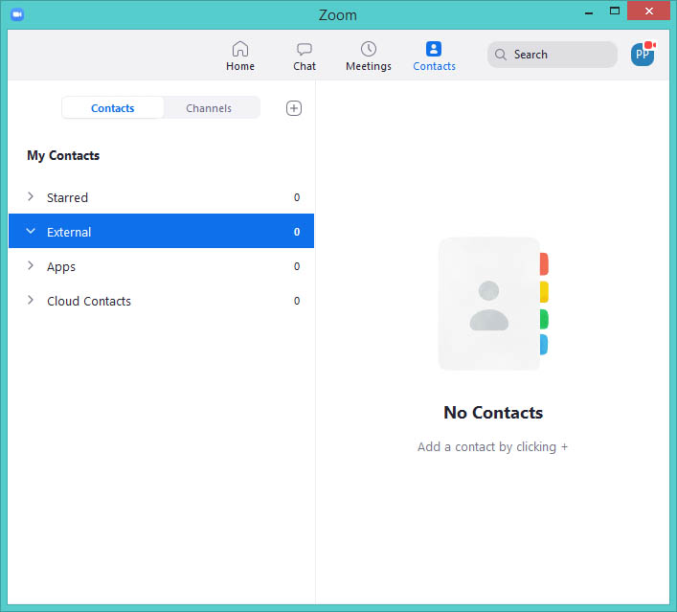

**Figure 5.3.** In the Contacts panel, click on the  on the line with **Contacts**, **Channels**. This pops up a menu with the **Add Contact** option. Click on that .

1. 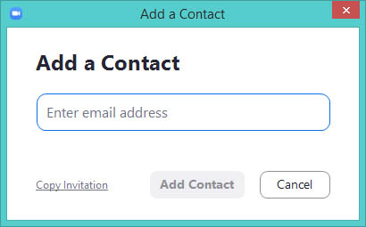
2. 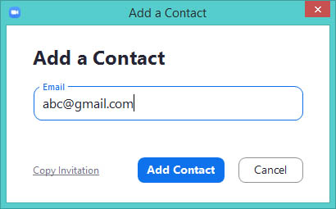

**Figure 5.4.** Then enter their email address to the **Add Contact popup** a) and press the **Add Contact button** in b) after you have entered their email. This will email the contact invitation. However, if it fails to send the email, do it manually by clicking on **Copy Invita**tion and then email it using your email program. After starting their Zoom app if it is not running, recipients then click on the URL in the Add Contact email you have just sent them.

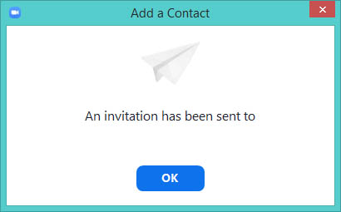

**Figure 5.5.** They will then see a message that **the Add Contact Invite** was sent. At this point you must wait until they **Accept** or **Decline** your add contact invitation.

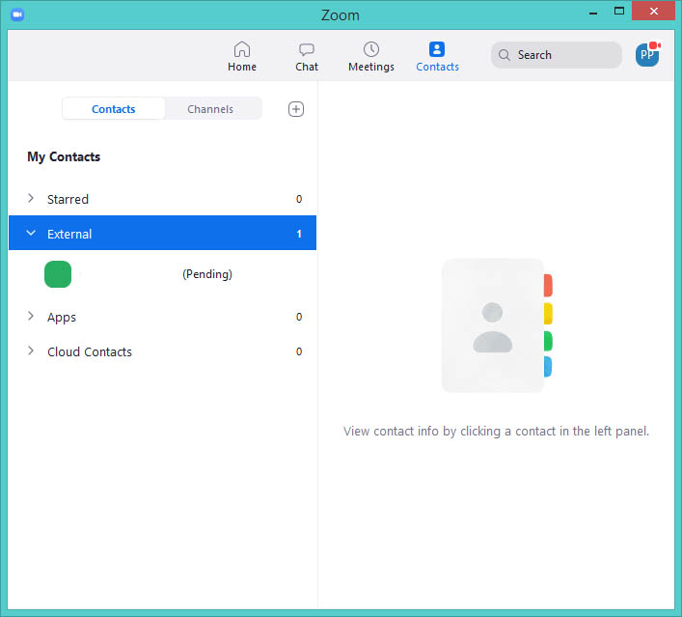

**Figure 5.6.** Your **Contact List** shows their contact as being **Pending**. If they **Accept** it, the (**Pending)** label goes away and you will have their contact name in your contact list and your contact name will appear in their contact list.

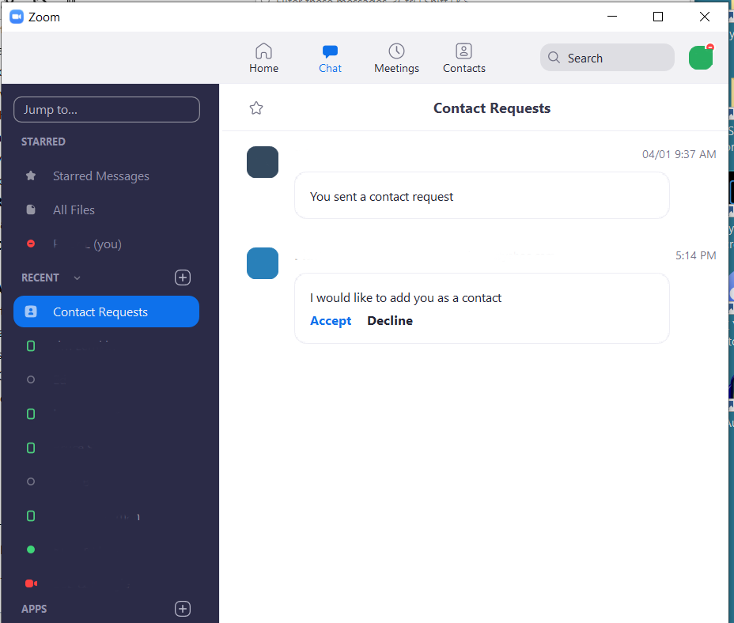

**Figure 5.7.** The recipient of the **Add Contact Request** will have the request popup in a **Contact Requests Window**. They can **Accept** it or **Decline** the request. After they accept your request, you will have their contact name in your contact list as and your contact name in their contact list.

**Appendix A. Doing a Zoom invite using “Copy Invitation” and your email program**

If you did *not* use the email buttons described in **Section 2.2**. You can manually invite people using your email program. Instead of clicking on the one of the email buttons shown in **Figure 2.8** popup window, click on the **Copy Invitation** button in the lower left of that window. This copies the invitation to the computer clipboard (this is *equivalent* to the copy from Copy & Paste using control-C). Note: on a tablet it might only have **Copy URL**, in which case click on that.

Next, start the email program on your device. You may have to minimize your Zoom meeting to get to your email program. For example, start your mail program or if you are using Web browser email, access your **AOL** or **Yahoo** tab **Mail** or whatever email program you are using. Click on **Compose** (some programs say **Write**) to create an email to send to everyone who will be in the meeting. Enter the email addresses of the people you want to send the invite in the “**To**:” email field. Then enter a **Subject** line something like: “Please click on the following link to join a Zoom meeting.” Then, **first** click on the *message* part of the email where you want to paste the clipboard. **Then**, paste the previously copied clipboard Invite (see **Section 2.2**) by now typing Control-V. It will look something like the sample **Invite text example** shown in **Figure 2.9**.

**A.1 A review of how to use Copy & Paste for transferring text**

* First: **Select** what you want to copy by *dragging the mouse over what you want to copy*, e.g., the Invite link and/or password. Next, type **control-C,** which puts the copy into the clipboard.
* Before you paste the text that you have just copied, you need to go to where you want to paste it. For sending a Zoom Invite, that would be the message part of the email you are sending.
* Finally, after you have selected where you want to paste the clipboard, type **control-V** which pastes it into the email.
* Copy & Paste can be used by people who may want to copy and paste the Meeting ID and Password from the Invite when they want to join a meeting. Of course, they could just type in the Meeting ID and Password values, but that involves more effort instead of clicking on the join-meeting link.
* Your computer may have pull down menu entries for editing to do the *Cut, Copy, Paste, Select* operations. These may be used instead of using the above command key combinations. You can use the menu commands if you prefer.

**Appendix B. Settings in the Zoom App Client for controlling Meetings**

You may configure various meeting settings to control your Zoom session from your Zoom app. These will be the same for all Zoom sessions you do until you change the settings. The following figures show the various Zoom client settings options. For these examples, some of the options were set for more security, but you should set the options to suit your requirements. For more information on these settings, see the detailed  [Zoom discussion for client app settings](https://support.zoom.us/hc/en-us/articles/201362623-Changing-settings-in-the-desktop-client-or-mobile-app). They have specific details for different devices: [Windows](https://support.zoom.us/hc/en-us/articles/201362623-Changing-settings-in-the-desktop-client-or-mobile-app#collapsePC), [Mac](https://support.zoom.us/hc/en-us/articles/201362623-Changing-settings-in-the-desktop-client-or-mobile-app#collapseMac), [Linux](https://support.zoom.us/hc/en-us/articles/201362623-Changing-settings-in-the-desktop-client-or-mobile-app#collapseLinux), [Android](https://support.zoom.us/hc/en-us/articles/201362623-Changing-settings-in-the-desktop-client-or-mobile-app#collapseAndroid), and [iOS](https://support.zoom.us/hc/en-us/articles/201362623-Changing-settings-in-the-desktop-client-or-mobile-app#collapseiOS). ***It is suggested you review your setting that are appropriate for you.***



**Figure B.1** To bring up the Zoom client app **Settings** window, click on the gear icon in the upper right corner after you have started the Zoom App.



**Figure B.1.1** To bring up the Zoom client app **additional options pulldown menu,** click on the gear icon user icon in the upper right corner after you have started the Zoom App. You can **Check for Updates** and **Sign Out** of Zoom. As Zoom has been doing frequent updates, it is useful to update your version. If they require you to do an update (for some versions) before you can proceed, they will tell you when you try to join a meeting with an old version and force you to do the update. Otherwise, you can click on **Check for Updates** and it will either ask you to update or tell you that you have the latest revision.

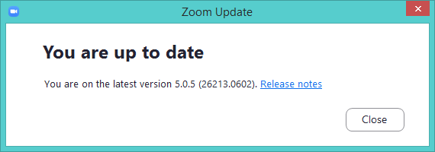

**Figure B.1.2**You can also use the **Check for Updates** to show you the Zoom revision number of your Zoom program. It will also have a link to the current Zoom revision history on Zoom.com.

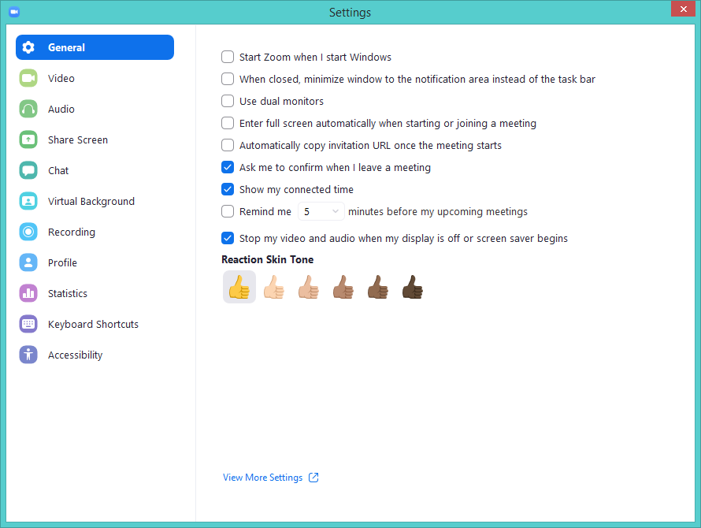

**Figure B.2** **General** settings in the Zoom App client. You can investigate the various setting by selecting one of the other general areas including **Video**, **Audio**, etc. You do not have to save the changes in the settings after you have checked or unchecked a selection – it is saved automatically. To bring up the **Zoom.com setting website**, click on the **View More Settings.** That brings it up in a Web browser and asks you to login before you can change your settings. The Zoom.com settings are shown in **Appendix C**.

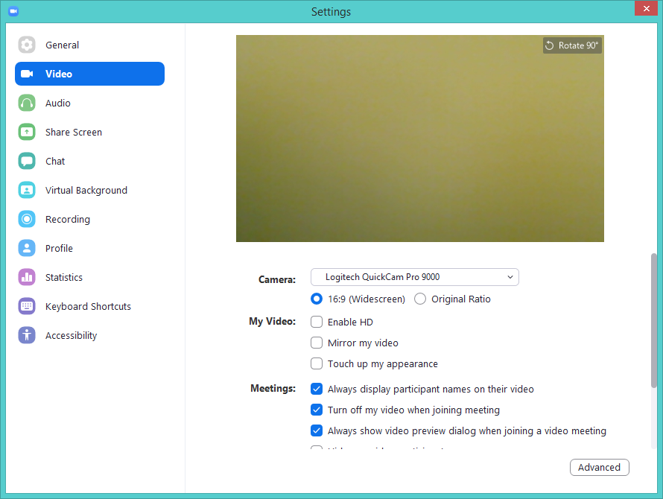

**Figure B.3 Video** settings. **Mirror my video** should be off if you hold documents up to the camera so they are readable.



**Figure B.3.1 Video** settings (continued). Press the **Advanced** button to get more video settings.

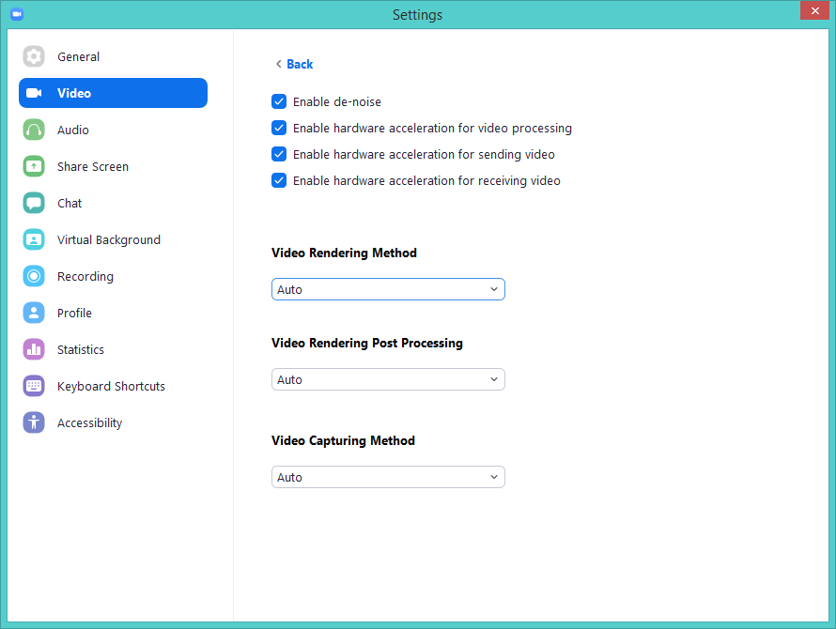

**Figure B.3.2** More **Video Advanced** settings.



**Figure B.4** **Audio** settings. If you will be using a microphone, setting **Automatically join audio by computer when joining a meeting** is a useful option. You can test your microphone and speakers.

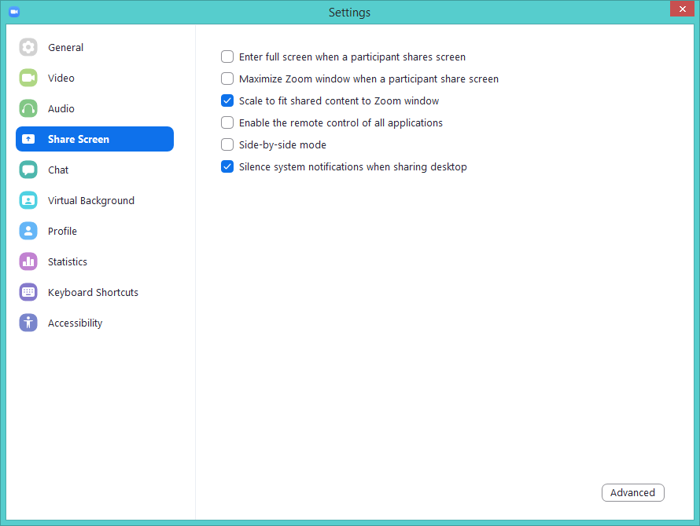

**Figure B.5** **Share Screen** settings. The screen sharing is also controlled by the Host in Zoom.com settings shown in **Figure C.1.4**.

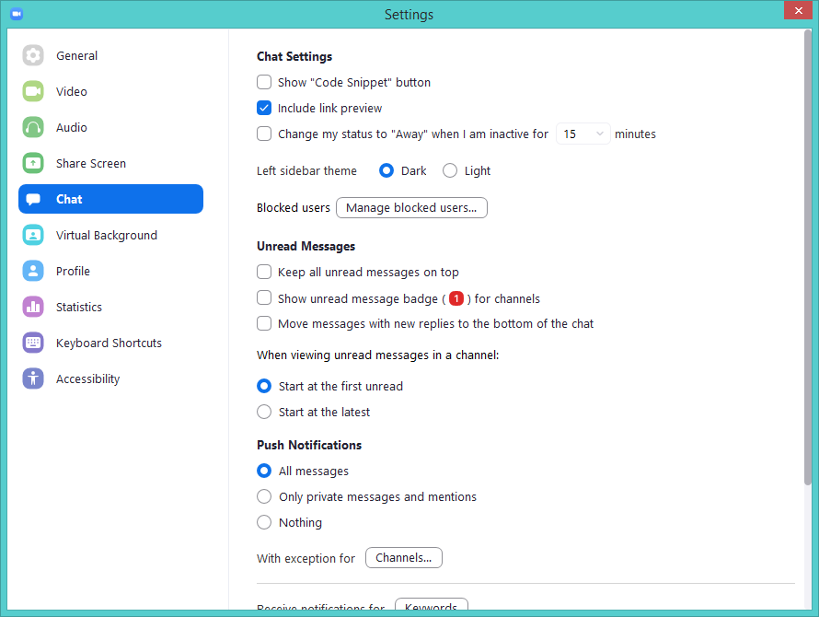

**Figure B.6.1** **Chat** settings.

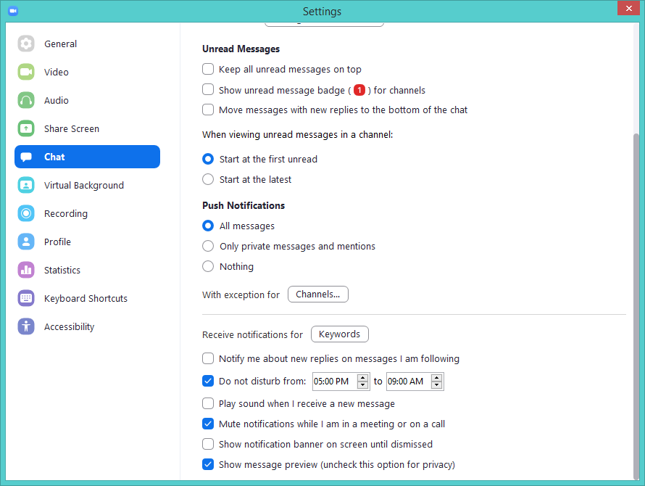

**Figure B.6.2** **Chat** settings (continued).

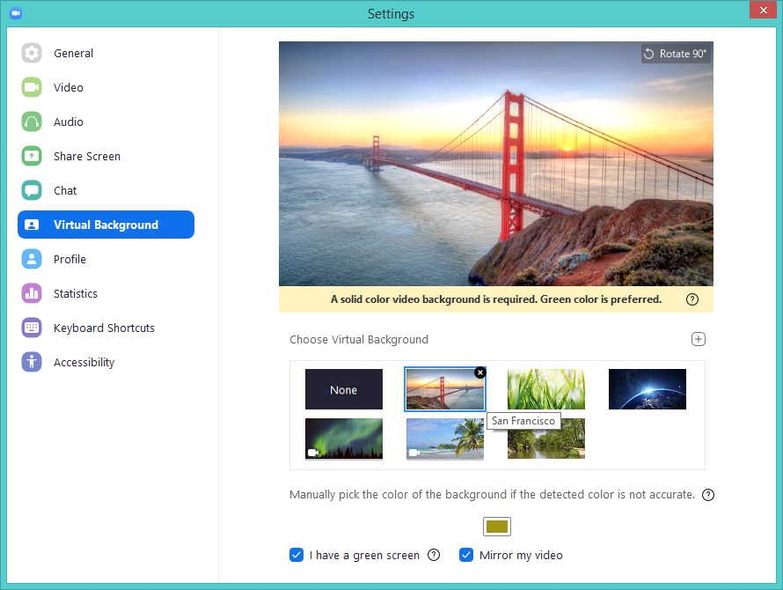

**Figure B.7** **Virtual Background** settings. The **Mirror my video** lets you flip you image left/right.

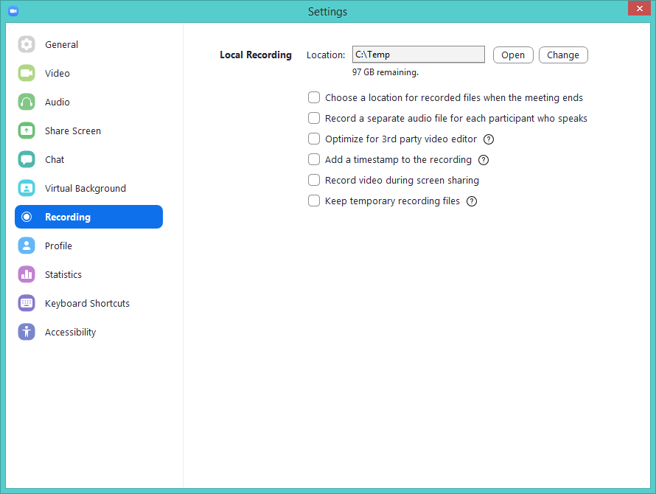

**Figure B.8** **Recording** settings. If you do not want to use **Record video**, disable all these options. The Host can disallow recording by changing the settings on their Zoom.com. See **Figure C.1.10.**



**Figure B.9** **Profile** settings. You can change your name, add a photo, etc**. View Advanced Features** brings up your settings on the Zoom.com site after it asks you to login.

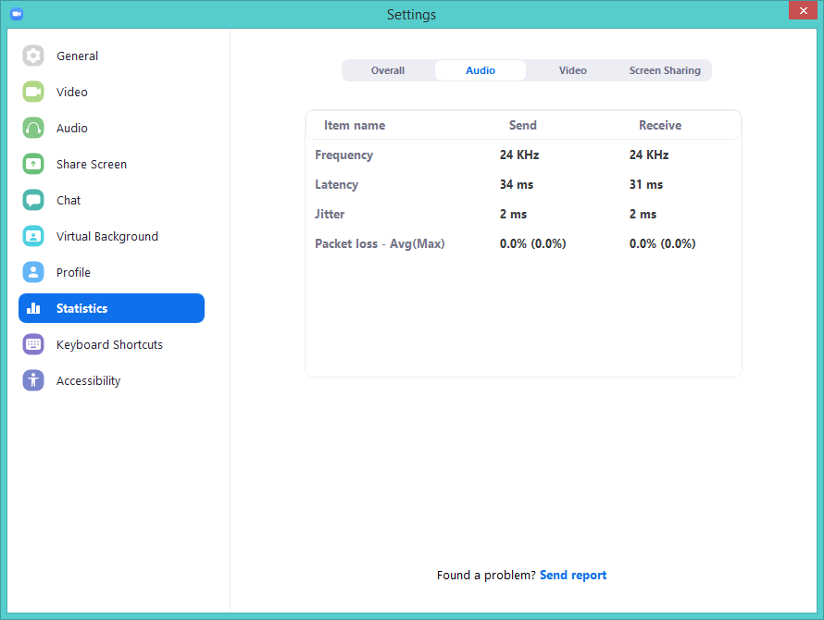

**Figure B.10** **Statistics** settings. The **Audio** and **Video** statistics show the latency, jitter and bandwidth. The **Overall** view shows the system resources you are using. The latency depends on your network connection and distance from the other participants.

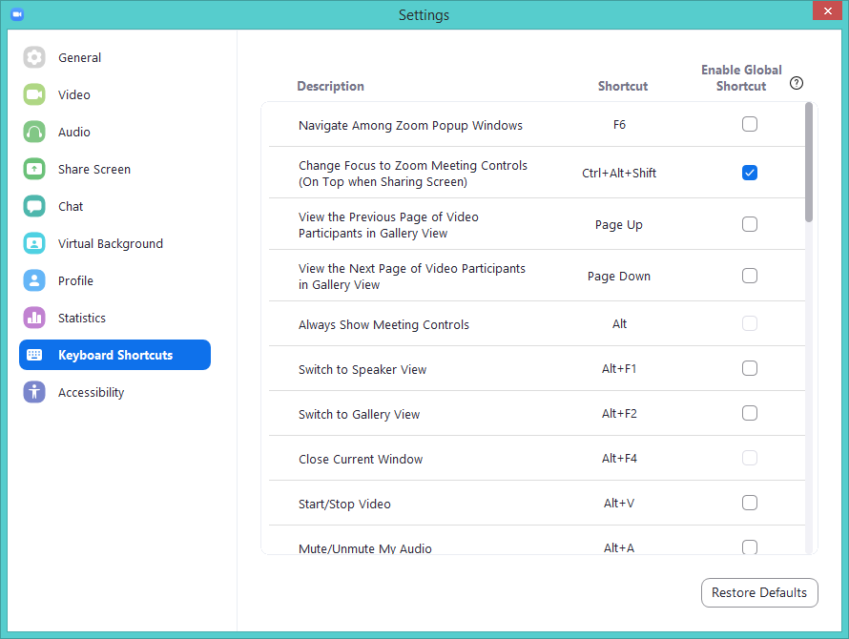

**Figure B.11** **Keyboard Shortcuts** settings. You do not have to use them unless you want to.

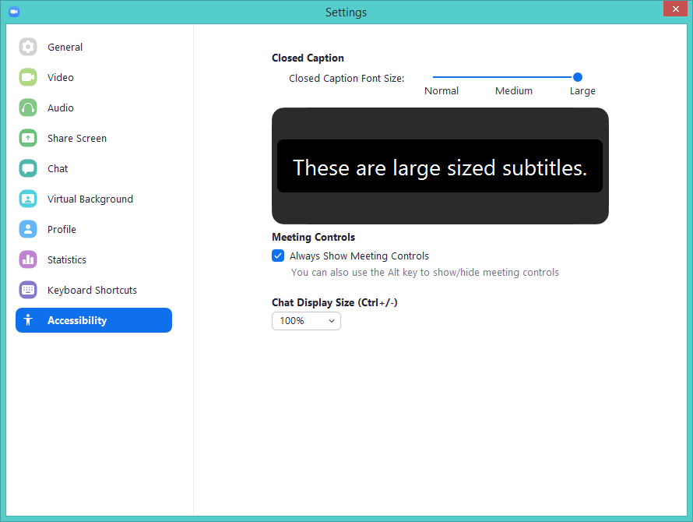

**Figure B.13** **Accessibility** settings. This is useful for people with poor vision.

**Appendix C. Advanced settings in the Zoom.com website for controlling Meetings**

(As of June, 2, 2020 for Zoom revision 5.0.4)

These setting are used by the Host to control what is allowed in meetings the initiate. To bring up the **Zoom.com setting website**, click on the **View More Settings** in your Zoom app. This brings up your Web browser and asks you to login to Zoom before you can change your settings. The following screen shot figures enumerate the options. For these examples, some of the options were set for more security, but everyone should set their options for their needs. See the detailed discussion for [settings for hosting Zoom meeting set on Zoom.com](https://us04web.zoom.us/profile/setting) for more information on these settings*.* ***It is suggested you review your settings and set them so they are appropriate for you.***

[](https://us04web.zoom.us/)

*New Features*

*Our latest release went live on April 12th. Please subscribe to our* [*blog*](https://blog.zoom.us/) *and visit our* [*release notes*](https://support.zoom.us/hc/en-us/articles/204758419-New-Updates-for-Web) *to stay up-to-date on all the latest enhancements to your account. To update to the latest version of Zoom, visit our* [*download*](https://zoom.us/download) *page.*

*Important Notice:*

*To enhance the security on your account, starting* ***April 5th****, (2020) meeting passwords and Waiting Rooms will be turned on by default to protect your privacy. As the meeting host, there are some steps you’ll need to take to familiarize yourself with these changes and ensure that your attendees can join your upcoming meetings seamlessly. Please* [*read this article*](https://support.zoom.us/hc/en-us/articles/360041408732) *for step-by-step instructions.*

**Figure C.0** Zoom’s Notice (June 2, 2020) at top of your Zoom.com settings when you log into Zoom to inspect or change your settings. Zoom leaves messages about recent changes at the top of your settings. The links in this figure point to pages on Zoom.com.



**Figure C.1** There are three main sets of settings. The main set is **Meeting**. Scroll down and select the settings you want. If you will not be recording the video, just disable all settings in **Record** settings. And if you are not using a **Telephone** number for Zoom, you can set those settings to use for **Computer Audio**, i.e. Internet only.



**Figure C.1.1** Additional options. These control on how you will require and use **Passwords**. If you don’t want to use passwords, you can disable the use of passwords here. Zoom has disabled this option (*Locked by admin*) for the free version.



**Figure C.1.2** Additional options about **Passwords.**



**Figure C.1.3** Additional options that control the use of **Chat** in a meeting.



**Figure C.1.4** Additional options that control **Screen Sharing**. You can pass files if **File Transfer** is enabled through the **Chat** window using drag and drop. It is useful to **Always show meeting control** toolbar to avoid having to find it when it is not visible on the screen.



**Figure C.1.5** Additional options about sharing a **Whiteboard** and allowing others to do **Remote Control** during screen sharing can be dangerous. Only use with trusted participants.



**Figure C.1.6** Additional options including **Renaming** participants. This controls whether the Host can use **Breakout Rooms.** However, it puts an additional burden on the Host to check who is in the Waiting Room and then Admit or Reject them.



**Figure C.1.7** Additional options enabling using **virtual backgrounds**.



**Figure C.1.8** Additional options involving using **Waiting Rooms.** The Host must make a point of checking the Participants window to allow or reject people in the waiting room to join the meeting.



**Figure C.1.9** Additional options when **Scheduling** a meeting.



**Figure C.1.10** Additional options for **Recording video**. If you do *not* want to allow participants to record video for your meetings, disable these options.



**Figure C.1.11** Additional options for using a **Telephone** with Zoom.

**Appendix D. Glossary of terms used in Zoom**

* Audio (**Mute**/**UnMute**) buttons- the control buttons on your Zoom window that you use to start and stop using your microphone. However, the Host is able to mute and unmute the participants microphones.
* **Breakout Rooms** – are sub-meetings that can be set up by the Host (if enabled in the settings) by assigning individual participants to these separate sessions. The Host may then bring the breakout rooms back into the main meeting room.
* **Chat** button – Zoom lets you send messages to Everyone or a private message to an individual Participant in the Chat window which you pop up by pressing the **Chat** button.
* Contact – Zoom gives you the ability to start a meeting with one or more contacts who have registered with Zoom and with whom you have added mutual contact information.
* Device – desktop, laptop, cell phone, tablet used to participate in a Zoom video conference. It should have a microphone to speak in the conference. To see images, it should have a camera as well. Devices usually have a camera-microphone. Desktops usually do not, but you can buy a webcam (camera with a microphone) to attach to the desktop.
* Host – the person who starts and controls the meeting.
* Meeting – a video and/or audio conference conducted over the Internet where each person is on a separate device.
* Participant – a person joining a meeting who is using their own device. Of course, or a group of people in the same room sit in from of the device’s camera/microphone.
* **Participants** Zoom window – what participants see when they are in a meeting. They can Invite other participants, mute/unmute themselves, etc.
* **Record** button – is an option to let the Host and/or participants record the video meeting. It can be enabled/disabled by the Host.
* Screen Sharing – the display of the screen or a window on a participant’s screen to the meeting, if they are allowed.
* Security – the restrictions of a Zoom meeting primarily set by the Host starting the meeting, but also restricted by the participants in their Zoom clients.
* Settings (on Zoom client) – settings that you can set on the client to control your Zoom sessions. See **Appendix B**. for a list of the options.
* Settings (on Zoom.com) – after you log in to your Zoom account, you can set and change additional settings to control your Zoom sessions. See **Appendix C**. for a list of the options.
* **Video (Start/Stop**) buttons – the control buttons on your Zoom window that you use to starting and stopping your own video.
* Waiting Room – is a place where people joining the meeting are placed by Zoom until they are allowed or rejected in the meeting by the Host. The Host goes to the Participants window to do the Allow/Reject for individual participants or they can **Allow All** participants.
* Whiteboard – is a whiteboard that may be enabled in **Screen Share** mode. It may be controlled by the Host or can allow participants to draw on it as well.
* Zoom client – the application program or ”app” that runs on the participant’s device. This is installed when you accept your first Zoom email invite and click on the link. Or you can download it directly from Zoom.com.
* [Zoom.com](https://Zoom.com/) – the Zoom website where you can acquire a zoom account, download Zoom, change options. It contains extensive documentation.

**Appendix E. A few** **articles about best practices, pros and cons of Zoom meetings**

**Best Practices**

* Consumer Reports, [**It's Not Just Zoom. Google Meet, Microsoft Teams, and Webex Have Privacy Issues, Too**](https://www.consumerreports.org/video-conferencing-services/videoconferencing-privacy-issues-google-microsoft-webex/?EXTKEY=EE052BDAC&utm_source=acxiom&utm_medium=email&utm_campaign=20200519_cromc_engagewkly). CR evaluated videoconferencing privacy policies and found these services may collect more data than consumers realize. By Allen St. John, April 30, 2020.
* Chronical of Higher Education, [**8 Ways to Be More Inclusive in Your Zoom Teaching**](https://www.chronicle.com/article/8-Ways-to-Be-More-Inclusive-in/248460). By Kelly A. Hogan and Viji Sathy, April 08, 2020
* CNET, [**How to use Zoom like a pro: 13 hidden features to try at your next meeting**](https://www.cnet.com/how-to/how-to-use-zoom-like-a-pro-13-hidden-features-to-try-at-your-next-meeting/). Learn to change your background, your audio and video settings, and how to share your screen. Alison DeNisco Rayome, April 28, 2020.
* Groove Blog, [**16 Advanced Zoom Tips for Better Video Meetings**](https://www.groovehq.com/blog/zoom-tips-and-tricks). Alex Turnbull.
* W.Post, [**And the award for best video chat app goes to..**](https://www.washingtonpost.com/video/business/technology/upgrade-with-geoffrey-fowler/and-the-award-for-best-video-chat-app-goes-to/2020/05/20/1d4b5454-577d-4d9d-825b-3a9a1e28e8e3_video.html?itid=ap_geoffreya.%20fowler). Compares Facebook Rooms, FaceTime, Google Meet, Houseparty, Skype and Zoom and crown some surprising winners. By Geoffrey A. Fowler and Heather Kelly, May 20, 2020.
* HBR, [**How to Combat Zoom Fatigue**](https://hbr.org/2020/04/how-to-combat-zoom-fatigue). by Liz Fosslien, Mollie West Duffy, April 29, 2020
* BBC, [**The reason Zoom calls drain your energy**](https://www.nytimes.com/2020/05/12/us/coronavirus-updates.html). By Manyu Jiang, April 22, 2020.
* OM, [**Five stages of Zoom**](https://om.co/2020/05/10/five-stages-of-zoom/). By Om Malik, May 10, 2020.
* W.Post Internet Culture, [**Video-chatting tips from Al Roker, Tamron Hall and other pros, since we’re basically socializing on TV now**](https://www.washingtonpost.com/technology/2020/05/07/zoom-tips-lighting-skype-google-hangouts-video-chat/). By Travis M. Andrews, May 7, 2020.
* Cornell Univ, [**Webinars for Teaching Online | Center for Teaching Innovation**](https://teaching.cornell.edu/webinars-teaching-online)**,** Winter, 2020.
* Slate.com, [**My Child’s School Zoom Meetings Are a Disaster. What should the teacher do differently?**](https://slate.com/human-interest/2020/04/zoom-teaching-tips.html) By Matthew Dicks, Katie Holbrook, Cassy Sarnell, and Amy Scott, April 02, 2020.
* Law.com, [**Tips for Successful Mediations Using Zoom videoconferencing**](https://www.law.com/therecorder/2020/04/07/tips-for-successful-mediations-using-zoom-videoconferencing/?slreturn=20200405173820), Suzzanne Segal, April 7, 2020.
* Zoom.com, [**Meeting and Webinar Best Practices and Resources**](https://support.zoom.us/hc/en-us/articles/209743263-Meeting-and-Webinar-Best-Practices-and-Resources)**.**
* Zoom.com, [**Best Practices for Securing Your Zoom Meetings**](https://zoom.us/docs/doc/Securing%20Your%20Zoom%20Meetings.pdf)**.**
* Inc.com, [**11 Dos & Don'ts of Video Conferencing Etiquette**](https://www.inc.com/ss/video-conferencing-best-practices), By Nicole Marie Richardson.
* Wired.com, [**Tips for Using Zoom: OK, Zoomer! How to Become a Videoconferencing Power User.**](https://www.wired.com/story/tips-for-using-zoom/) As the pandemic pushes work online, Zoom is the new office. Follow these tips to get the most out of those video meet-ups. By Boone Ashworth, March 25, 2020.
* NY Times, [**How to Prevent ‘Zoombombing’ in a Few Easy Steps**](https://www.nytimes.com/2020/04/07/style/zoom-security-tips.html). There are a few things you can do to make your video conferences more secure. Taylor Lorenz, April 9, 2020.

**Zoom recent articles**

* Zoom.com, [**Upgrade / update to the latest version - Zoom Help Center**](https://support.zoom.us/hc/en-us/articles/201362233-Upgrade-update-to-the-latest-version)
* Zoom.com,[**Zoom video tutorials - Zoom Help Center**](https://support.zoom.us/hc/en-us/articles/206618765-Zoom-Video-Tutorials)
* Zoom.com, [**Top 20 Most Commonly Used Support Resources**](https://support.zoom.us/hc/articles/360042982391).
* Zoom.com, [**5 Things to Know about the New Zoom 5.0**](https://blog.zoom.us/wordpress/2020/04/27/its-here-5-things-to-know-about-zoom-5-0/), April 27, 2020 (new security changes)
* Zoom.com**,** [**Zoom 5.0 webpage**](https://zoom.us/docs/en-us/zoom-v5-0.html?zcid=1231)or the [**Release Notes**](https://support.zoom.us/hc/en-us/sections/201214205-Release-Notes?zcid=1231) **for all versions**.

**Security**

* Consumer Reports, [**Zoom Calls Aren't as Private as You May Think. Here's What You Should Know**](https://www.consumerreports.org/video-conferencing-services/zoom-teleconferencing-privacy-concerns/). Videos and notes can be used by companies and hosts. Here are some tips to protect yourself. By Allen St. John, updated: March 30, 2020.
* W.Post, [**Big Tech is coming for Zoom: Google makes video chatting service Meet free.**](https://www.washingtonpost.com/technology/2020/04/29/google-meet-zoom-competitor/)
* Google said it would make its Meet video conferencing service free for everyone, with no time limits for several months. By Rachel Lerman, April 29, 2020.
* Wired.com, [**The Zoom Privacy Backlash Is Only Getting Started**](https://www.wired.com/story/zoom-backlash-zero-days/). A class action lawsuit. Rampant zoombombing. And as of today, two new zero-day vulnerabilities. By Lily Hay Newman, April 1, 2020.
* Wired.com, [**How to Keep Your Zoom Chats Private and Secure**](https://www.wired.com/story/keep-zoom-chats-private-secure/). Every Zoom meeting is based around a 9-digit meeting ID. If that ID becomes public somehow, or trolls find it in a web search or guess it, they can pop into your chats and disrupt them. By David Nield, April 5, 2020.
* NY Times, [**Why Zoom Is Terrible. There’s a reason video apps make you feel awkward and unfulfilled. Video**](https://www.nytimes.com/2020/04/29/sunday-review/zoom-video-conference.html). By Kate Murphy, April 29, 2020.
* PC Mag, [**How to Prevent Zoom-Bombing.**](https://www.pcmag.com/how-to/how-to-prevent-zoom-bombing)  Zoom is the video calling app of choice during the COVID-19 pandemic. Unfortunately, some features make your meetings susceptible to hijacking. Learn how to stop bad actors and keep your calls secure. By Jill Duffy, April 16, 2020.

**Early problems with Zoom security**

* The Intercept, [**Zoom’s Encryption Is “Not Suited for Secrets” and Has Surprising Links to China, Researchers Discover**](https://theintercept.com/2020/04/03/zooms-encryption-is-not-suited-for-secrets-and-has-surprising-links-to-china-researchers-discover/). By Micah Lee, April 3 2020.
* The Intercept, [**Zoom Meetings Aren’t End-to-End Encrypted**](https://theintercept.com/2020/03/31/zoom-meeting-encryption/), Despite Misleading Marketing. Micah Lee, Yael Grauer, March 31, 2020.

**\* * * * * * * * * * * * * * * * \***